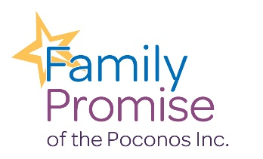
Are you…?
- A Senior for the 2022/2023 school year?
- Able to push, pull, and/or lift at least 20lbs?
- Able to stand for an extended period ?
- Wanting to make a difference in your community?

Family Promise of the Poconos, offering emergency shelter to homeless children and their families, has volunteer opportunities. Help is needed reading to children in shelter, helping students with homework, organizing and putting away donations and outdoor clean up.

If you are interested, please call
(570) 420-8589
If you plan to volunteer, please complete the form. (OVER)

If you have any questions, please call us at 570-420-8589 or email at cmanager@ptd.net or FPromise@ptd.net
Family Promise of Monroe
Student Volunteer Form

Your Information
Name: ___________________________________________ Date: _____________
Phone number: __________________ Email:_______________________________
School: ___________________________________________ Year: _____________

Emergency Contact:
Name: _______________________________ Phone: ____________________
Relationship to you: ____________________

Why are you looking to volunteer?
____________________________________________________________________________________________________________________________________________________________________________________________________________________________________________________________________________

By sign this application, I confirm that the information provided within is correct and complete. I agree that I will not disclose any confidential information obtained while volunteering and that I will protect the privacy of other volunteers, donors, and families served by Family Promise.
______________________________________________ _________
Applicant’s Signature Date
______________________________________________ __________
Guardian of Applicant’s Signature Date

