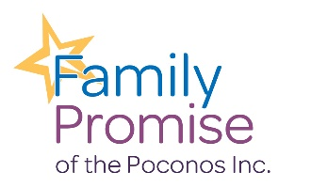

Family Promise of Monroe County Volunteer Application for Individuals

Name: Date:
Address:

Town: State: Zip:
Home Phone: Cell Phone: E-Mail Address: Occupation/Profession: _
Employer:

City: State: Zip:

Previous Volunteer Experience:
_ Organizations and/or affiliations:

Why would you like to volunteer with Family Promise?

Expertise, Hobbies, Special Skills you’d like to share:

Volunteer interests: (Use a separate sheet if necessary to describe specific qualifications)

- Weekend Volunteer ◻ Office Volunteer (phones, administrative, computer skills)

- PR/Marketing ◻ Web Development (knowledge of Word Press)

- Graphic Design □ Overnight Host □ Career Counseling ◻ Mailings

- Workplace Readiness ◻ Computer Training □ Financial/Credit Repair ◻ Newsletter

- Fundraising ◻ Legal Services □ Health/Wellness ◻ Social Media

- Tutor (ESL) (GED) (Child) ◻ Photography/Video ◻ Realtor

- Home Repairs/Carpentry □ Cleaning/Painting ◻ Auto Maintenance/Repair □ Event Help

- Interested in learning more about Board Membership

Are you over 18 years of age? Languages spoken other than English:

Are you qualified to give legal advice?

I am available: days _
evenings/nights
weekends

Does your employer make grants to non-profit organizations?

Does your employer match your charitable contributions?

How did you hear about us?

Emergency Contact:
Name/Phone Number: Relationship

Please provide a reference: (Other than Family Member)
Name/Phone number Relationship

Have you ever been convicted of any crime including sex-related offenses? No Yes

If yes, please explain

Do you need Community Service Hours? No Yes

If yes, please explain. How many hours needed _ School Court Ordered Other

By signing this application, I confirm that the information provided within is correct and complete. If requested, I agree to provide any information necessary for a complete background check.

I agree that I will not disclose any confidential information obtained while volunteering and that I will protect the privacy of other volunteers, donors, and the families served by Family Promise.

Applicant’s signature Date:

P.O. Box 1021, Stroudsburg, PA 18360

